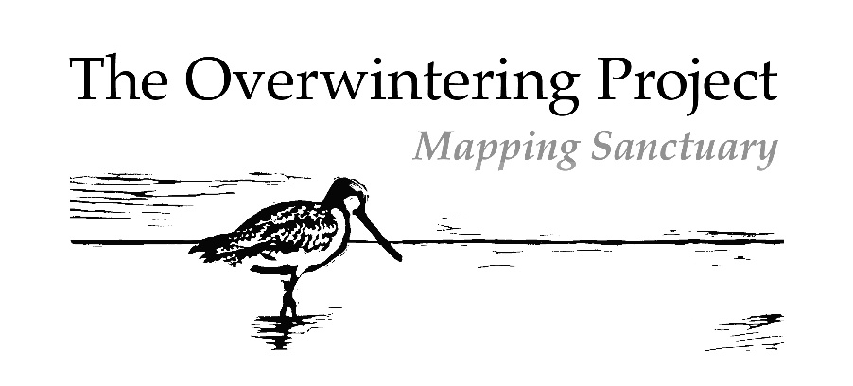

The Overwintering Project Print Portfolio Artists' Agreement

l, ______________________________ agree to donate two prints from the same edition to The Overwintering Project Print Portfolio, in the understanding that:

- My prints will pass into the property of the Overwintering Project Co-ordinator, Kate Gorringe-Smith, to be exhibited or sold in order to fulfil the aims of Overwintering Project as deemed fit by the Overwintering Project Co-ordinator.

- One of the above prints is to become part of the Overwintering Project Print Portfolio.

- The remaining print will be available for sale, with the proceeds from its sale to be donated to Birdlife Australia to fund migratory shorebird research and conservation.

- The intention is for the Overwintering Project Print Portfolio to be exhibited in venues in Australia and possibly other countries. The Overwintering Project Co-ordinator may organise exhibitions and other displays featuring The Overwintering Project Print Portfolio, in whole or part, on any terms at her absolute discretion, as long as the prints are identified as part of the Overwintering Project Print Portfolio.

- The Overwintering Project Print Portfolio may be loaned out to other exhibition organisers and venues for exhibitions not organized by the Overwintering Project Co-ordinator, on any terms at her absolute discretion, as long as the prints are identified.as part of the Overwintering Project Print Portfolio.

- Images of the artwork I submit to The Overwintering Project Print Portfolio may be reproduced by any means for promotional purposes in digital and print media, as well as for any Overwintering Project educational & information materials, and any other purpose The Overwintering Project wishes. These permissions are granted in perpetuity.

- AII proceeds from the Overwintering Project Print Portfolio prints, arising from sale, exhibition, reproduction or otherwise out of The Overwintering Project will be donated to Birdlife Australia to fund migratory shorebird research and conservation.

- My administration contribution of $25 will go toward the running and exhibition costs of The Overwintering Project.

- l retain the right to claim authorship of my prints and will be identified as the author of my prints in use or reproduction in connection with The Overwintering Project.

- It is envisaged that The Overwintering Project Print Portfolio may eventually become part of the collection of a public institution. If the Overwintering Project Co-ordinator Kate Gorringe-Smith determines that this is unlikely or impractical, she may sell or otherwise deal with the prints at her discretion.

Signed: Date:

